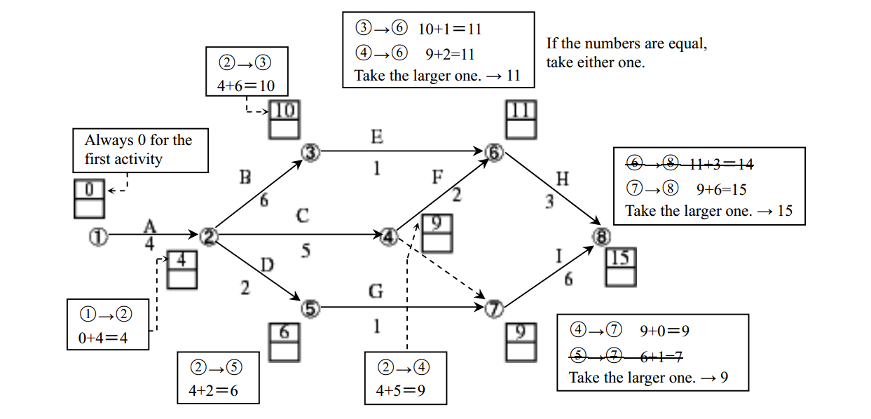

When there are two arrows point at one node. We will take the larger one.